**Breast Pumps:**

mommyXPRESS: (844) 641-2255, [www.mommyxpress.com](http://www.mommyxpress.com/)

Some Tennessee hospitals provide breast pump rental. We recommend checking with your hospital of choice when completing your delivery pre- registration or childbirth education class.

WIC provides breast pumps to eligible moms separated from their babies or with special circumstances. Contact your local WIC clinic or Shelby County Breastfeeding Coordinator for details.

Call your insurance company for assistance obtaining a breast pump, now covered by most providers under the Affordable Care Act!

## Tennessee Laws Protecting Breastfeeding

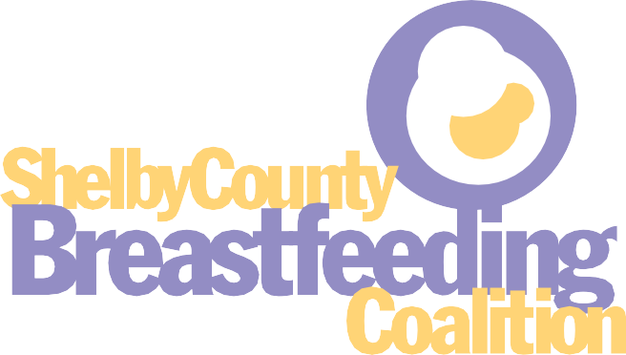

Our Mission:

To protect, promote, and support breastfeeding in Shelby

A mother may breastfeed in any public or private place she is authorized to be. (TCA 68-58-101)

Breastfeeding shall not be considered public indecency or nudity, obscene, or sexual conduct. (TCA 68-58-102)

Local governments shall not prohibit breastfeeding in public by local ordinance. (TCA -68-58-103)

Employers must accommodate breastfeeding mothers at work. (TCA 50-1-305)

County through the assistance of the medical profession, the public health system, and consumers by educating physicians and other health care providers, encouraging “Baby-friendly” practices in all Shelby County hospitals, and by educating the public through community outreach activities.

## Free Apps for your phone

Baby2Sleep—Free message with safe and healthy sleep information Text4Babies—

free text information service designed to promote maternal and child health Check out our website for videos, apps, and more at [www.shelbycountybreastfeeding.org](http://www.shelbycountybreastfeeding.org/)

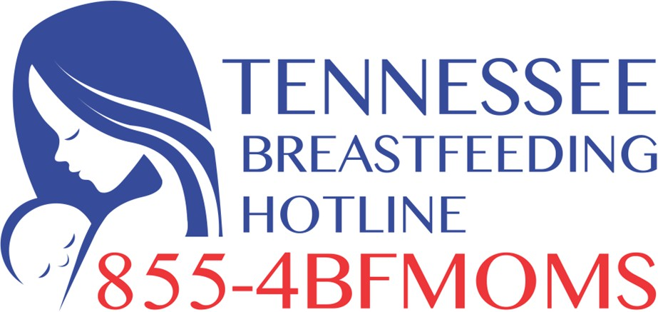Hot-lines

Tennessee Breastfeeding Hot-line available 24/7

(855) 423-6667

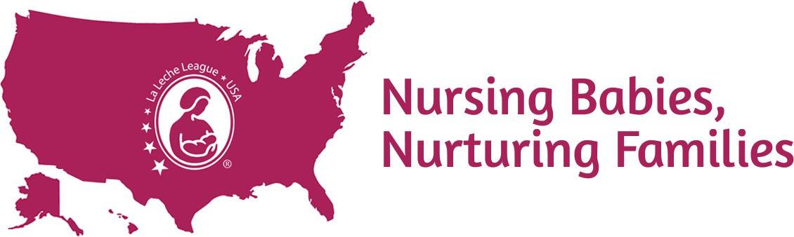USA Helpline through La Leche League USA (877) 452-5324

(Must leave message & will receive return call)

Office on Women’s Health available M-F 8-5 CST (800) 994-9662

**Disclaimer:** The Shelby County Breastfeeding Coalition compiled this list of available breastfeeding resources in Shelby County and surrounding areas but neither guarantees nor endorses any services mentioned here. SCBC is not liable for any damages arising out of the use of information provided here.



# Contact us at

[shelbycountybreastfeeding@gmail.com](mailto:shelbycountybreastfeeding@gmail.com)

[www.shelbycountybreastfeeding.org](http://www.shelbycountybreastfeeding.org/) Like us on Facebook!

Updated 2024

# Consultations, Visitations, and Support Groups

*Cost, accepted insurance, & availability will vary. Call/email to schedule appointments and for additional information about individual and group consultations, classes, & support..*

### Individual and Private Practice Consultation & Support

All Better Pediatrics:

Linda Bowman, IBCLC Marcia Garcia, BA, IBCLC (901) 761-1880

Allison Stiles, MD, FAAP, FACP, IBCLC: Memphis Internal Medicine & Pediatrics (901) 276-0249

Angie Whatley, RN, IBCLC: (870) 636-5231

[arwhatley166@gmail.com](mailto:arwhatley166@gmail.com)

Anna Wilson, CLC:

(901) 300-0408

[gaeabirthingco@gmail.com](mailto:gaeabirthingco@gmail.com)

April Sims, CLC:

(901) 438-7485

Bring It On Out:

Donna Ross, CLC (901) 649-5811

[donnaross1968@yahoo.com](mailto:donnaross1968@yahoo.com)

Chanielle Talbird, MS, CLS, CD(DONA): (901) 907-5036

[vineyardpastries@gmail.com](mailto:vineyardpastries@gmail.com)

Jessica Balderson, SLP, CLC (901) 619-8590

Kaila Matthews, CLC (901) 603-0454

[www.whatthedoula.com](http://www.whatthedoula.com/)

Kimathi Coleman, CLC (901) 310-5372

[creationswithak@gmail.com](mailto:creationswithak@gmail.com)

Laurelwood Pediatrics:

Megan Harris, CLC:

(559) 288-6271

Milk Medic

Shan McLean, BSN, RN, IBCLC Stefanie Logan, BSN, RN, IBCLC (901) 651-4489

[info@themilkmedic.com](mailto:info@themilkmedic.com) [www.themilkmedic.com](http://www.themilkmedic.com/)

Midsouth Lactation Consultants: Joni Rose, MS, RD, LDN, IBCLC, RLC

Brandi Jordan, MS, RD, LDN, IBCLC, RLC

901) 826-6385

[support@midsouthlactationconsultants.com](mailto:support@midsouthlactationconsultants.com) midsouthlactationconsultants.com

My Mama Body:

Emily Mulqueen, CLC (917) 331-9643

[emily@mymamabody.com](mailto:emily@mymamabody.com) mymamabody.com

Pediatric Associates:

(901) 377-2711

Pediatric Consultants – Collierville: (901) 457-2880

Pediatrics East:

Brandi Jordan, MS, RD, IBCLC Cindy Earle, MSN, RN, IBCLC (901) 757-3535

River City Pediatrics (Baptist Medical Group)

Kristi McDonald, RD, IBCLC (901) 761-1280

[kristina.mcdonald@bmg.md](mailto:kristina.mcdonald@bmg.md)

Susan Rook, PT, CLC (901) 602-4460

[cebirth901@gmail.com](mailto:cebirth901@gmail.com) https://cebirth.com

Webbmark Health Solutions, LLC Larita Taylor, PhD, MPH, CLC [www.Webbmarkhealth.com](http://www.Webbmarkhealth.com/)

731-215-0385

### Hospital and Lactation Support Services Organizations

*Baptist Memorial Health Care*

Desoto:

(662) 772-3296

Memphis (Women’s):

Support Group and General Questions (901) 227-9873

Lactation Services

(901)-227-9620

Tipton:

(901) 475-5410

*Breastfeeding Sisters That Are Receiving Support (BSTARS)* [TPyles@bstars.org](mailto:TPyles@bstars.org)

Facebook: Memphis BSTARS

*Breastfeeding USA Memphis Chapter*

Jessica Smith (901) 579-0536

[jessica.s@breastfeedingusa.org](mailto:jessica.s@breastfeedingusa.org) Facebook: Breastfeeding USA Memphis Chapter

*Early Success Coalition:*

(901) 577-2500

earlysuccesscoalition.com

*LaLeche League of Memphis:*

Kristin Hildebrand (901) 244-3511

[lllmemphiskristin@gmail.com](mailto:lllmemphiskristin@gmail.com)

Legend of Lactation Credentials

*Methodist Le Bonheur*

Germantown:

(901) 516-6893

South (Memphis):

(901) 516-3475

Olive Branch (662) 932-9328

*Regional One Health (ROH)* Community Program Coordinator for Childbirth Services:

(901) 545-8449

regionalonehealth.org/womens-services/ classes/

Lactation Services (901) 545-7736

[lactationroh@regionalonehealth.org](mailto:lactationroh@regionalonehealth.org)

*Saint Francis Hospital Park:*

(901) 765-1761

*Saint Jude Children’s Research Hospital:*

(901) 595-3315

*Classes for St. Jude employees only*

*Shelby County Agencies*

Baby Café (901) 222-9980

WIC Clinics:

(901) 222-9000

*Sundara Wellness Center*

(901) 321-5803

sundarawellness.com

Rivka Braverman, IBCLC

(901) 683-9371

Le Bonheur Pediatric Groups Breastfeeding Clinics (For Le Bonheur Patients Only)

(901) 432-1591

Tallita Oseguera, CNM, WHNP-BC Text: (310) 430-5964

talitathemidwife.com

Toni Hill, DEM, CLC (North Mississippi) (662) 269-4643

IBCLC: International Board Certified Lactation Consultant: A professional who specializes in the clinical management of breastfeeding which

includes: preventive healthcare, patient education, nutrition counseling, and therapeutic treatment. An IBCLC is certified by the International Board of Lactation Consultant Examiners and works in a variety of settings, providing leadership, advocacy, professional development, and research in the lactation field.

CLC: Certified Lactation Counselor: A professional in lactation counseling who has demonstrated the necessary skills, knowledge, and attitudes to provide clinical breastfeeding counseling and management support to families who are thinking about breastfeeding or who have questions or problems during the course of breastfeeding/lactation.

CLS: Certified Lactation Specialist: A professional in lactation counseling who has demonstrated the necessary skills, knowledge, and attitudes to provide clinical breastfeeding counseling and management support to families who are thinking about breastfeeding or who have questions or problems during the course of breastfeeding/lactation.